Purpose
Through collaboration and accountability Foerster Elementary School’s proposed School Improvement Plan provides scholars with opportunities to attain content mastery and increase student achievement as a result of the implementation of school interventionist supported pull-out/ push-ins, after school tutorials, and additional academic reinforcement provided through the Extended Year Program (EYP).
Activities Completed
A Campus Intervention Team (CIT) committee was established to strategically organize the implementation of the plan. The CIT is responsible for development, implementation, and monitoring of the School Improvement Plan, monitoring of student performance, and determination of student inventions and support service. The CIT committee consisted of the campus principal, dean of instruction, and two general education teachers. Initially an anonymous online survey was constructed to gauge the need for additional support to faculty, additionally current and prior campus wide assessment data was reviewed. Upon receipt of the surveys and review of the campus intelligence, three catalysts for improving student achievement was ascertained; school interventionist supported pull-out/ push ins, after school tutorials, the Extended Year Program (EYP).
Within the SIP the CIT addressed approaches to invite participation and support by teachers, students, caregivers. Student participating in the implementation of school interventionist supported pull-out/ push ins, after school tutorials, and/or continued academic reinforcement provided through the Extended Year Program (EYP) will be provided with special treats and prizes, eligibility for educational electronics and bike drawings, multiple giveaways, free dress-day passes. Parents of these scholars will have the same opportunity to win various restaurant and store gift cards on the basis of consistent student attendance, participation, and academic achievement. Lastly, teachers will be afforded with the same opportunity to win various gift cards, additionally they will receive free jean day passes, extra duty pay, and will occasionally be granted exclusion from dismissal duty.
In order to ensure proper facilitation of the plan, it was determined by the committee that one elected teacher from each grade level would participate in big-ticket specialty professional developments to strengthen and train grade level colleagues to service students in the area of lesson planning, small groups, positive framing, student- teacher relations, and other effective research-based best practices. This school year Foerster was approved for a waiver to have one additional early release day per month in order to dedicate the added time to deliver targeted professional development and address academic deficits. Some component of the training include; how to motivate and promote learning with the student population and guidance lessons for educators in order to support and build teacher capacity when working with at-risk populations. Each month there is a focus on various topics based on data and the campus needs assessment. These topics include but are not limited to: RTI/ IAT, Lead4ward DDI, Literacy and Mathematics, Diffusing situations, Campus Culture, Small Group 101, Scholar Test Taking, strategies, and anxiety. Teachers will be able to interact with one another and practice various strategies in order to receive immediate feedback. Resources for the SIP was requested and distributed through the dean of instruction.
Foerster Elementary School serves a population of approximately 730 students with 42 teachers. Traditional general school programs for grades Pre-K through 5th, traditional bilingual programs for Pre-K through 3rd, and an ESL program for grades Pre-K through 5th and specialized programming for Behavior Support (BSC), Preschoolers Acquiring Learning Skills (PALS), and Life Skills is offered on campus. Our population consist of 59.14% African American-inclusive of 8.3% African refugees, 25% Hispanic, 13% Asian, <1% White, and <1% American Indian. The vast majority of our population lives in the surrounding apartment complexes in the Westbury area where crime and low socioeconomic demographics are prevalent. About 64% of students live in Pines of Westbury, which offers Section 8 public housing. This large percent of apartment complexes contributes to the 37.5% mobility rate and is directly linked to the lack of consistent achievement across grade levels and content areas. It is also a causal factor in the recent refugee population being enrolled by various agencies such as Catholic Charities and Bhutanese American Association of Houston; refugee students make up 17.3% of total enrollment. Additionally, 98% of Foerster’s students are eligible for free/ reduced lunch.
Analysis of the data reveals that an achievement gap exists between students of different racial or ethnic backgrounds (African- American, Hispanic, and Asian) and Economically Disadvantaged students, whom make up 98% of the student body. Current STAAR and IOWA/ Logramos data reflects a trend that continuously enrolled students consistently out-perform those who are annually enrolled. Foerster’s attendance rate has fluctuated between 95- 96% over the past 3 years. Likewise, the African American population is performing much lower than other major sub populations. In all subjects African American scholars scored at 51% whereas Hispanics scored at 71% and ELL scored at 61%.
The results of the “Your Voice” survey revealed that only 48% of parents feel that the school is safe and secure. Foerster received an overall rating from staff and parents of “C” for the 2014- 2015 school year. The staff revealed through their surveys that the campus could improve in areas such as counseling services, school safety, and academic readiness.
The campus data strongly suggest that the African American population is under performing. The proposed SIP will provide students and faculty with necessitated support, resources, and continuous professional development that targets all student populations, with special interest in African American scholars. By providing students with the implementation of school interventionist supported pull-out/ push ins, after school tutorials, and additional academic reinforcement provided through the Extended Year Program (EYP), students will receive beneficial rigorous supplemental instruction and interventions to strengthen core subjects as well as a means for strong interventions for scholars who are not academically on grade level.

Review of Literature
Who is failing to learn adequately? Researchers have identified common practices such
as School Interventionist Supported Pull-Out/ Push-Ins, After School Tutorials, and Extended Year Program (EYP) that have yielded promising results. School’s primary goal is to increase students’ achievement. Differentiated instruction is an instructional concept that maximizes learning for all students regardless of their varied skill levels, abilities, learning styles, personalities, interests, motivation levels, or background. When a teacher differentiates instruction by offering varied learning experiences, he or she uses the best teaching practices and strategies to create different pathways that respond to the needs of diverse learners. It is hypothesized that supplemental programs play a critical role in the continued support of students at every grade level in mastering the academic objectives required to satisfy promotion standards and demonstrate preparedness for the next grade level.
School Interventionist Supported Pull-Out/ Push-Ins
There are several intervention models offering supplemental support that exist in schools as they attempt to address students who fall short of academic success. This review of literature supports push-in and pull-out models. A push-in model may take two different forms. One is to have the teacher sit with one or more students during lessons delivered by the classroom teacher, to individually guide them to better understand and gain from the instruction being provided to all the students. Another possibility is for the teacher to work separately with one or more students in need, providing intensive reteaching of the lessons on which the students are struggling. A pull-out model is a structure in which students in need of extra help are taken out of their regular classroom to receive individual or small group specialized instruction in another location.
The authors Jarzyna-Ingles, Anne; Schletz, Tara; and Young, Melissa (2010), examine two models of third grade math intervention at two different elementary schools. School A, a diverse, suburban school, used pull-outs of underachieving students while School B, a private, urban school, intervention used push-in intervention to instruct on grade-level students. At each school, the focus on math instruction is not based on whole group instruction, but individualizing math instruction and accommodating each student. The results of the research demonstrated benefits of both intervention modules show the effectiveness of intervention strategies in terms of student academic growth. According to Jarzyna-Ingles, Schletz, and Young (2010), students are able to focus intensely on concepts and skills that are integral to classroom achievement through intervention. The authors also suggest that differentiation and intervention time allows greater focus on consistency for critical thinking skills and flexible grouping. These essential elements are an important piece to this ever growing educational movement. According to research it seems that differentiation in different schools with different demographics pose positive results in learning and behavior.

After School Tutorials
Tutoring is promoted within higher education in order to encourage learning and to prevent dropout among at-risk students. Most of the research on tutoring generally finds it to be moderately effective at improving academic achievement. For children who face academic or behavioral obstacles to success during the school hours, the after-school hours can be a time to attempt to eliminate these barriers and improve the education of the whole child.
The authors Terri Rothman and Mary Henderson (2011), examine one ethnically diverse urban central New Jersey public school district that included three elementary schools, one middle school, and one high school. The district is classified as an Abbott district, which means it meets specific criteria, including low socioeconomic status, evidence of substantive failure of thorough an efficient education, a large percentage of disadvantaged students who needs an education beyond the norm, and the existence of an excessive tax for municipal services. According to Rothman and Henderson (2011), tutoring is particularly beneficial among children from disadvantaged socioeconomic backgrounds, with learners showing greater than average gains in reading and mathematics achievement and less absenteeism than nonparticipating counterparts. The authors Rothman and Henderson (2011), also indicate that the borderline students who received after-school tutoring performed higher on standardized test scores in areas of mathematics and language arts than borderline students who did not participate in tutoring.

Extended Year Program (EYP)
Nothing is more important for your child than a solid foundation in reading and math. In the summer of 2014, 29 HISD campuses implemented the model known as Extended Primary Year, designed to give primary students the reinforcement and extra help they need special attention that will set them on a path to future success. The program included two sessions. The first session will review course work and skills from the previous grade, and the second session will give youngsters a head start on reading and math work for next school year.
An area of particular concern to researchers has been the learning loss that can occur over the long summer break. Several studies have shown that summer vacation has a disproportionately negative impact on learning for students from lower socio-economic backgrounds, and to make matters worse, this impact may be cumulative. According to the National Education Association (NEA) many schools offer extended year programs as a strategy for improving or enhancing student achievement. Extended learning opportunities provides children with academic achievement beyond the traditional school day. The evidence suggests that extended school time might be particularly beneficial for students who are most at risk of failing.
Every child has the capacity to succeed in school and in life. Yet far too many children, especially those from poor and minority families, are places at risk by school practices. Through effective supplemental programs, all students who need this extended time will meet the required promotion standards, be prepared for success at the next grade level, and be on-track to graduate with their peers.
Evaluation of Project
The SIP includes suggested evaluation strategies for educators to implement when working with at-risk students include but are not limited to:
- Written Records: Written records provide objective, narrative records of student performances, strengths, needs, and progress and negative/positive behaviors.
- Authentic Tasks: Authentic tasks are genuine activities that occur in a real-life context.
- Checklists, Scales or Charts: Checklists help identify and record students' levels of achievement by rubric levels (1,2,3,4), by letter grade or numerical value, or simply by acceptable/unacceptable.
- Conferences: Conferences include meetings between the student/parent/teacher and or principal where progress is checked and goals for growth are established and agreed upon.
- Contracts: Contracts are agreements or goals (verbal or written) set by the teacher/parents and the student. These can be most helpful when they are displayed on top of the student's desk. Contracts are often used in behavior modification.
- Demonstrations: Presentations by one student or by a group of students provide a way to demonstrate the skills used in the completion of an activity or the acquisition of curricular outcomes/expectations. Examples of presentations include skits, lectures, lab presentations, debates, and multimedia shows.
- Field Trips** (EYP): Field trips provide an opportunity to collect data, explore a particular place, experience something new and unique, collect specimens. Games provide excellent opportunities for simulations and small and large group assessment.
- Interest Inventories: student responses to questions designed to find out past experience and or current interest in a topic, subject or activity
- Tests, Exams, and Quizzes: Tests are very helpful tools for determining and measuring student achievement and performance. Tests exams, and quizzes come in many forms and varieties.
- Peer Evaluation: Peer evaluation involves having peers in a class or group review and evaluates the work of fellow students.
- Portfolio Assessment: Portfolio assessment relies on authentic samples of genuine student work to evaluate achievement and performance. A portfolio is a collection of student work that shows progress and achievements. Portfolio assessment should include student participation in selecting the content, specific criteria for judging the content, and evidence of student self-reflection.
- Rubrics: Rubrics provide guidelines for measuring achievement. Most rubrics describe the learning outcomes, give clear performance criteria, and provide a rating scale or checklist. Some rubrics give examples as well.
- Self-Evaluation: Self- evaluation involves obtaining student reflections about their learning goals and their progress in achieving those goals.
- Student Journals: Student journals are most often personal records that discuss learning activities, experiences, strengths, interests and needs.
- Student Portfolio: An 'on-going' student-maintained file in which all items represent progress, often included is a written reason why the student values the work. Drafts and final copies are both acceptable.
- Subject Area Portfolios: a portfolio of student work and reflection related to a particular subject or curriculum area; students are encouraged to present this portfolio to others as an accountable practice
- Teacher Observations: Teacher observations are regular, first-hand observations of a student documented by the teacher.
- Video and Audio: Video and audio records of student performance, achievement, and behavior provide helpful, valid assessment information (Venn n.d.)
Success of the SIP was evaluated on the basis of attendance of students participating and growth in academic performance measured by high frequency word (HFWs) for 1st and 2nd grade STARR standardized testing. Administration of IOWA/ Logramos testing was re-instated to the district after a couple decades of not being utilized; therefore there is no comparative data to analyze. The percentage of participation per grade level was substantial; Kindergarten 52%, 1st Grade 73%, 2nd Grade 43%, 3rd Grade 62%, 4th Grade 47%, and 5th Grade 58%. Data derived from the HFW administration test after the implementation of the SIP resulted in substantial increases in students who met goals. Students in 1st grade performance improved by 36% after 73% of these students had participated in at least one component of the SIP’s offered services. Students in 2nd grade performance improved by 36% after 73% of these students had participated in at least one component of the SIP’s offered services. In STAAR standardized testing, performance increase was also prevalent; 3rd Grade Reading increased 25% and Math increased 43%, 4th Grade Writing increased 2%, and 5th Grade Math increased 8% and Science increased by 29%.
GRADE LEVEL | PERCENTAGE OF PARTICIPATION WITH (SIP) SERVICES
KINDERGARTEN | 52%
GRADE 1 | 63%
GRADE 2 | 43%
GRADE 3 | 72%
GRADE 4 | 27%
GRADE 4 | 34%
GRADE 5 | 58%

HFW ADMINISTRATION | PERCENTAGE MET GOAL
GRADE 1 | 2014- 97%  2013- 61%
GRADE 2 | 2014- 91%  2013- 77

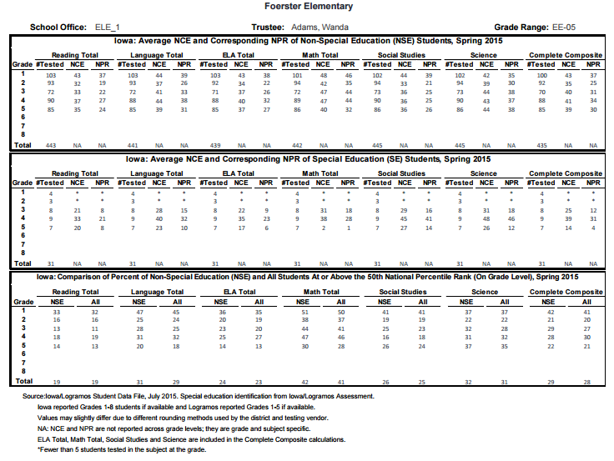

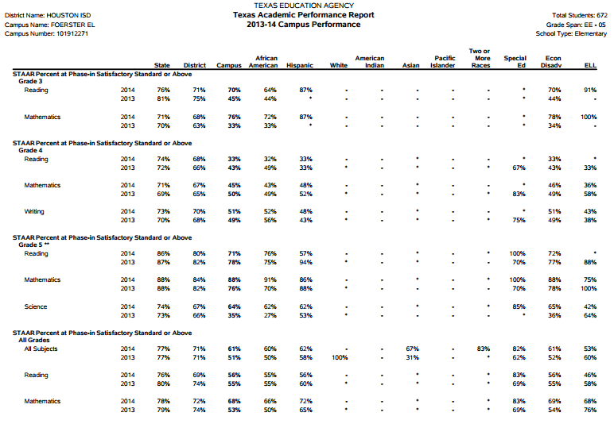
Reflection
As a developer of Foerster Elementary School’s, school improvement project, I became knowledgeable of the extensive examination of student data and underlying correlating components that must be encompassed in order to construct and facilitate an effective approach. As a future member of educational administration, one must consider the students, their caregivers, the role of the instructional and supportive staff, community stakeholders, professional development opportunities, student data, attendance, resources necessary to implement the plan, funding, and a plethora of many other facets
Foerster Elementary School serves a diverse student population with over 99% of our students receiving Free /Reduced Lunch. Special programs include Pre-K (Head Start), ESL, Bilingual, and Title I. The level of active parent involvement at Foerster Elementary is fairly undersized in accordance to the student population. As a result many educational opportunities and connections are null and void beyond the classroom. The SIP provides students with the opportunity to exercise learning and review of content in a supportive educational setting. On the basis of student participation in relation to student performance the plan was successful. It is imperative to continue implementing successful programs that have been proven beneficial for achievement of the student body.

REFERENCES

Jarzyna-Ingles, A., Schletz, T., Young, M. (2014) Differentiated Math Interventions for
Third Grade Students Using Push-In and Pull-Out Models. Masters of Arts in Education Action Research Papers. Pp. 45. Retrieved on October 29, 2015 from http://sophia.stkate.edu/ cgi/viewcontent. cgi?article=1044&context=maed
Caskey, M. Ph.D., Henderson, M., Rothman, T. (2011) Do School-Based Tutoring Programs Significantly Improve Student Performance on Standardized Tests. Volume 34 Number 6. National Middle School Association.
Retrieved on November 20, 2015 from http://files.eric.ed.gov/fulltext/EJ925246.pdf
Venn, J. (n.d.) Classroom Assessment - Ideas and Strategies. Retrieved on from October 7, 2015 from http://johnvenn.com/assessment/assessment_idea_and_strategies.html

