Houston Baptist University
Department of Education and Kinesiology
Lesson Plan Format
_____________________________________________________________

Subject: Reading Grade Level: 1st Time Estimate: 90 minutes

Unit: 1 Topic: Making Inferences

Goal(s): The learner will make making inferences when reading, watching, listening, or looking at various information.
Objective(s): The learner will draw on their prior knowledge and use the information from the pictures in the book, Animals Should Definitely Not Wear Clothing to communicate the inference the author is making in the text.

TEKS: ELA.1.RC.D Make inferences about text and use textual evidence to support understanding.

Materials/Resources/Technology needs:
- Animals Should Definitely Not Wear Clothing by Judi Barrett
- Construction paper
- Crayons
- Concept map

Vocabulary: make an inference, definitely, disastrous, manage
______________________________________________________________________

Instructional Procedures
Focusing Event:
- Put items in a bag and tell the students you found it on your way to school.
- Take the articles on one by one and make a list of them on the board or on chart paper
- Ask the students to make a case about the owner of the items in the bags
Example:
    - I can infer that this person likes the Mets (something with a logo on it)
    - I can infer that this person went to Chuck E Cheese (cup from Chuck E Cheese)
    - I can infer that this person is a girl (hair ribbon)
    - Etc.

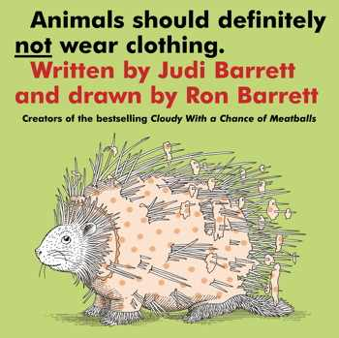

Teaching/ Learning Procedures:

- (Before reading this book to students, cover up all illustrations on each page so only the words can be seen.) Show students the cover of the book, Animals Should Definitely Not Wear Clothing by Judi Barrett and brainstorm all of the types of clothing that students’ wear. Ask students why animals should not wear clothing and make a list of reasons as a class.
- Explain that sometimes an illustrator gives clues about the author's meaning. In other words, the picture helps us make an inference.
- Tell students that they will make inferences about why the author thinks that certain animals should not wear clothing. Then use the illustrations to check the inferences. Start reading the story: "Animals should definitely not wear clothing...because it would be disastrous for a porcupine..."[show the text, but not the picture.] Then model your thinking aloud to students about why it would be disastrous for a porcupine to wear clothing.
- Emphasize throughout the lesson that students' inferences will be different because they are based on our background knowledge. Tell them that this knowledge is unique to all of us.
- As you read each page (again keep in mind illustrations are already covered up), ask why each animal should not wear clothing. Read the text, and give students two minutes to describe the picture in their mind to a partner. Continue through the book, encouraging students to make inferences between the text and what they know. *Stop before the page that says, "...because moose could never manage."

Formative Check (ongoing or specific):
- When you get to this page, ask each student to infer why a moose could never manage clothes. Have student take a piece of construction paper and crayons to draw and explain or write about their inferences.

- Have students continue the process with the next page (because opossums might wear it upside down by mistake). Ask students to share their inferences and illustrations and explain why they think that opossums might mistakenly wear clothes upside down.

Reteach (alternative used as needed): Review the skills of activating prior knowledge and making predictions. Use a different book and have students make inferences about what the author has intentionally left unstated.

Closure: Exit Ticket
- What is an inference?
- How can I infer when I read fiction?
- How can I infer when I read nonfiction?

Assessment/Summative Evaluation: Examine students' drawings and listen to their conversation to determine if they are comfortable using what they know to make inferences. Students should be able to use their prior knowledge along with the text to make an inference.
________________________________________________________________________
Modifications/Notes:
- Use graphic organizers, such as a concept map, a flow chart, or a KWL chart, to help map their thinking.

